Practical

The Model View Controller Pattern

Exercise 1

I want to introduce a new view to the Traffic Light application, so that I can display the traffic lights as a set of coloured circles, as illustrated in Figure 2.

So far I have managed to implement a ColorPanel class that displays three coloured circles, and I have modified the TLView class so as to display my ColorPanel. The Java code for the application will be sent to you by email.

The snag is that the application doesn’t really do what I want yet. TheColorPanel displays all three lights as if they were on, and does not update when the change button is pressed.

Download the start code from the module website, and complete the implementation as follows:

- Modify the ColorPanel class so that its constructor takes the model as an argument, and so that it has a member variable that is a reference to the model.

Note: the ColorPanel does not need a reference to the controller because it does not yet contain anything (like a button) that you would actually need to control.

- Modify the ColorPanel.paintComponent method so that it displays the lights in a way that reflects the state of the model. Note: the ColorPanel.paintComponent method will be automatically called when you call the repaint method on its parent frame. You do not need to (and should not) call paintComponent yourself.

Note on MVC: you should not need to modify the TLModel class (that’s one of the principal advantages of the MVC pattern). You should not need to modify the TLController class either.

Note on spelling: I have bowed down to US cultural imperialism and named my new class ColorPanel rather than ColourPanel (with a ‘u’). It’s probably best to do this because other classes in the Java library (e.g. Color) use this spelling, even though clever people like us can see that it is obviously wrong!

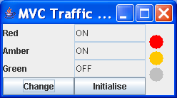
Figure 1 What I want

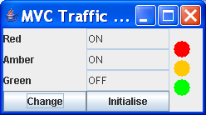
Figure 2 What I've got

Exercise 2: Enhancing the Controller

In this exercise we are going to give the controller some more work to do. The aim is to implement the ‘run’ and ‘stop’ buttons mentioned in the lecture. When you have finished you should end up with an interface that looks like that shown in Figure 3.

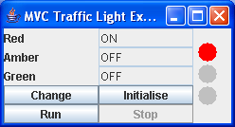
Figure 3 Traffic Lights With 'Run' and 'Stop' Buttons.
When the ‘Run’ button is pressed the following things should happen:

- The ‘Stop’ button should be enabled.
- The other three buttons should be disabled.
- The lights should start to change automatically at a preset interval (e.g. every second).

When the ‘Stop’ button is pressed the following things should happen.
- The ‘Stop’ button should be disabled.
- The other three buttons should be enabled.
- The lights should no longer change automatically.

You should modify the controller so that it takes responsibility for making sure that everything mentioned above happens. Here is a suggested way of doing it.

An object of the class javax.swing.Timer can be used to generate events of class java.awt.event. ActionEvent at preset intervals. We can arrange for the controller to create such an object and listen for the events it generates. The controller can respond to these events by calling the TLModel.change() method.

The controller will also have to enable and disable buttons on the view, so we will have to modify the view slightly so that it has methods that enable/disable its buttons.

We will also have to modify the layout of TLView so that its components are laid out in a 5x2 grid instead of the current 4x2 one.

Note that you should not need to alter the code for the TLModel or ColorPanel classes.

Figure 4 shows a partial class diagram for the suggested implementation (some classes and methods have been omitted).

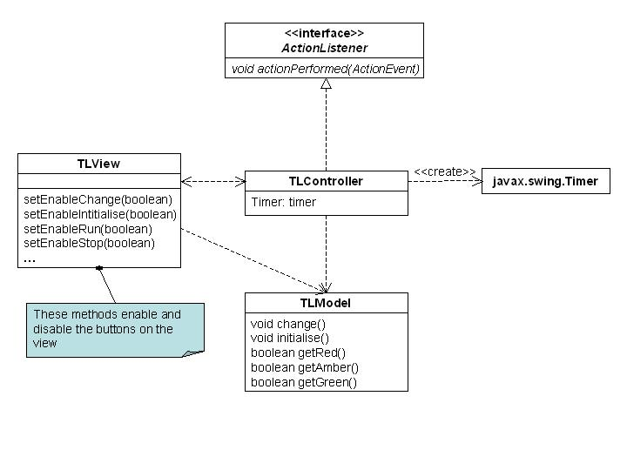
Figure 4 Partial Class Diagram for Suggested Implementation

